This program allows employees to apply time to jobs through a custom time sheet instead of by clocking into them. The time sheet can be launched either from the script 2 button on the GUI or from On Line System > File > Employee Timesheet (5114).

If your windows username is tied to your Global Shop User in System Support > File > User Security Maintenance, you will not be prompted to sign in. Otherwise you will need to sign in with your Global Shop username and password.

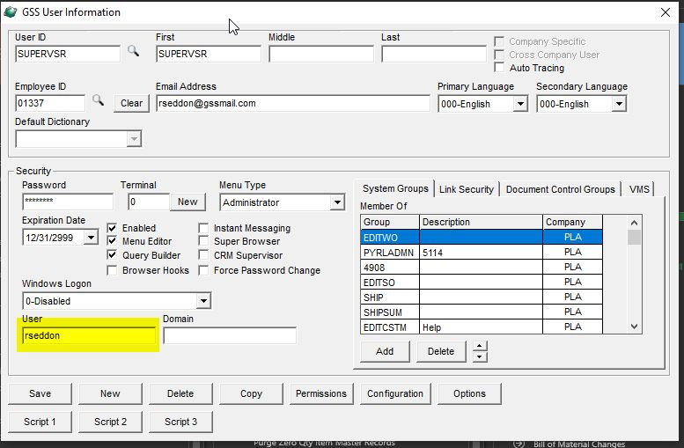System Support > File > User Security Maintenance

For each user that will be launching the time sheet from the GUI, the windows username will need to be set up here. This will be the username they use to log into their computer, it should be visible on the lock screen but can also be found in Settings > Accounts in windows.

If it is not set up, the user will be prompted to sign in with their Global Shop credentials.

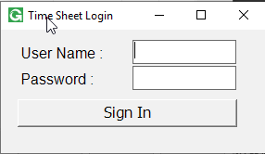

After signing in, if that user is a member of the PYRLADMN security group (which can be set in System Support > File > User Security Maintenance or System Support > File > Group Security Maintenance), they will be prompted asking whether or not to launch the time sheet as an administrator. Admins can view and edit other employees timesheets, and also have the ability to post them to Global Shop or unlock them for editing.

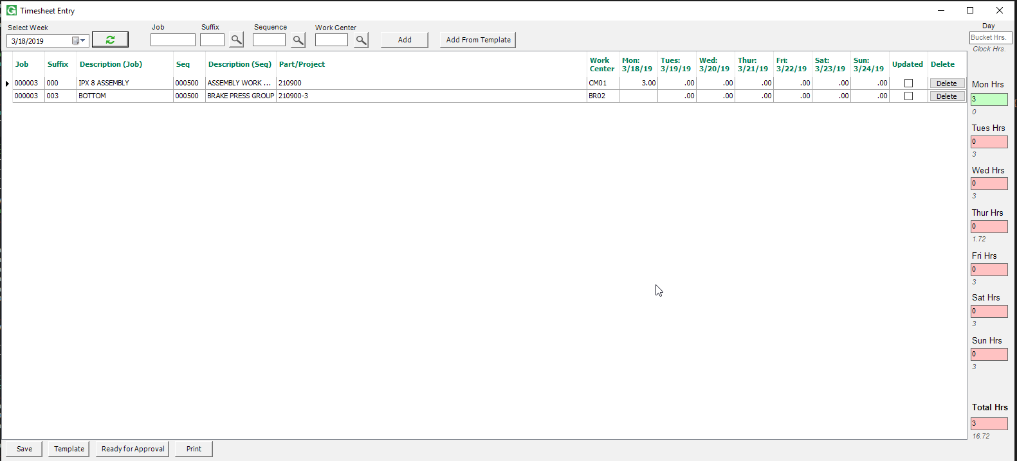

Select a week and click refresh to load records for that week.

Add jobs to the list by selecting a job and clicking add, or clicking add from template.

Click the Template button to maintain the template. Jobs can be added to the template, will remain there. At the start of a new week, the user can click the add from template button to add all the jobs from the template to the timesheet.

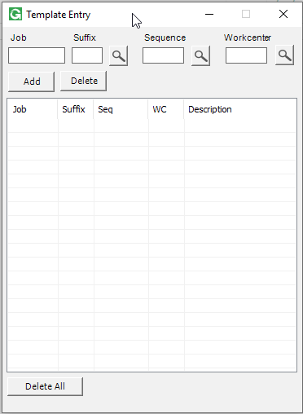

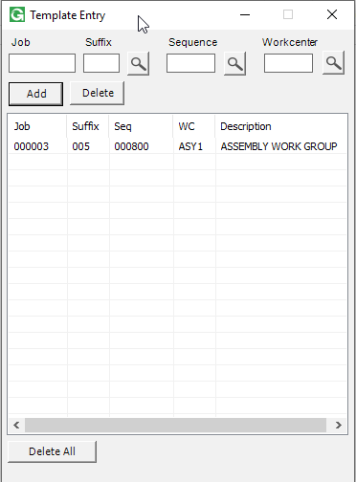

Enter time for jobs in the grid.

The bucket on the right hand side of the screen will update with the total time for that day. The employee's actual unapplied clock in time will load underneath the bucket. When the unapplied time is 0 (when the clock in time matches the timesheet time) the bucket will turn green.

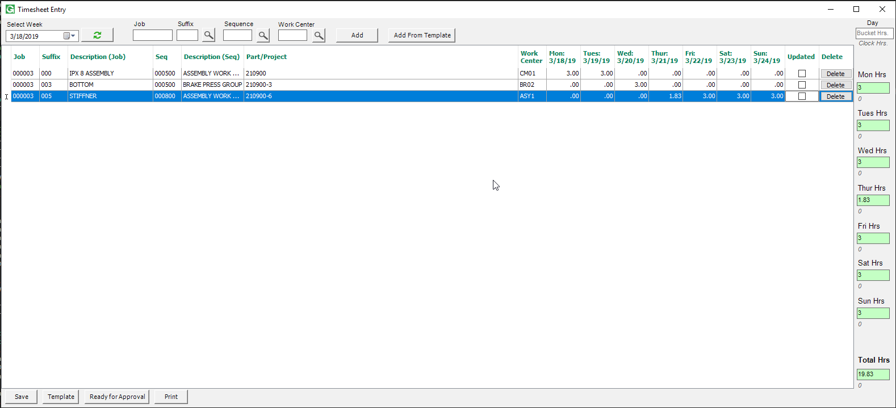

Click save to save the entries.

Click Print Button to print the timesheet for that week.

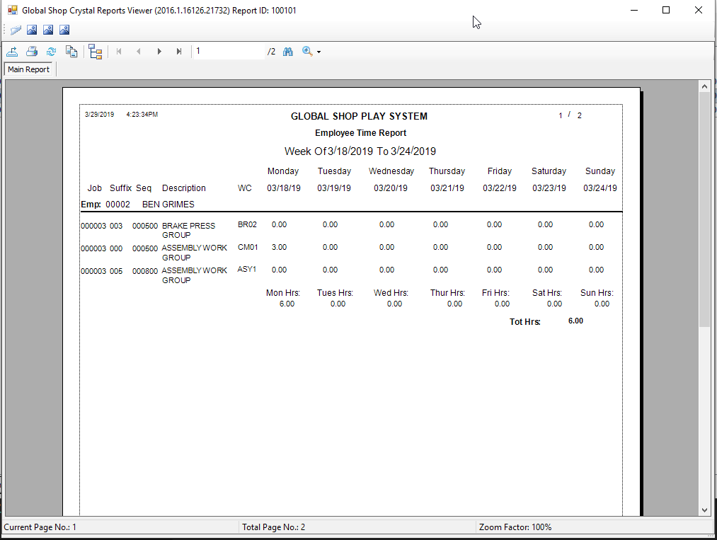

When done updating the time sheet for that week, click the Ready for Approval button to lock it and mark it as ready for an Admin to post.

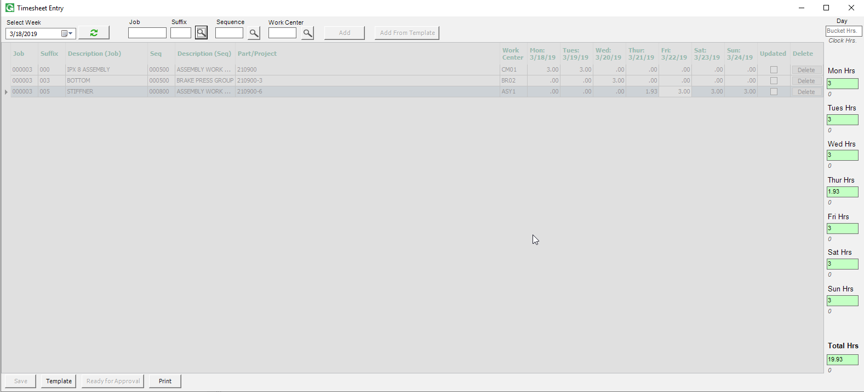

When launched as an admin, the user can view any employee/user's time.

Select an employee and week and click refresh to load the time.

The time sheet can be unlocked for editing by the employee by clicking the unlock button.

If the time is ready, the Lock/Post to GSS button can be clicked to apply the time to the jobs in GSS.

